**Soccer player performance analysis**

* The soccer team consists of unique player name of 17981. Each team belongs to a particular city
* Each team consists of a number of players. No player belongs to more than one team. . The league also records each player’s name ﬁrst name and second name wages , values , age , nationalities ,potential , club , penaliies ,strength and own physical attributes, is of a particular nationality, has his own kit number and other details.
* Every Players has his own statistics. The statistics are number of goals
* Teams play one another in a series of scheduled matches
* . The league records the score of each match. In addition, the league records, for each match, the number of goals scored by each player.
* Each Match has different number of goals scored in it at different stages in the match and scored by different players. It is scored in the database as the nth goal in the tournament, which is unique.

**POWER BI**

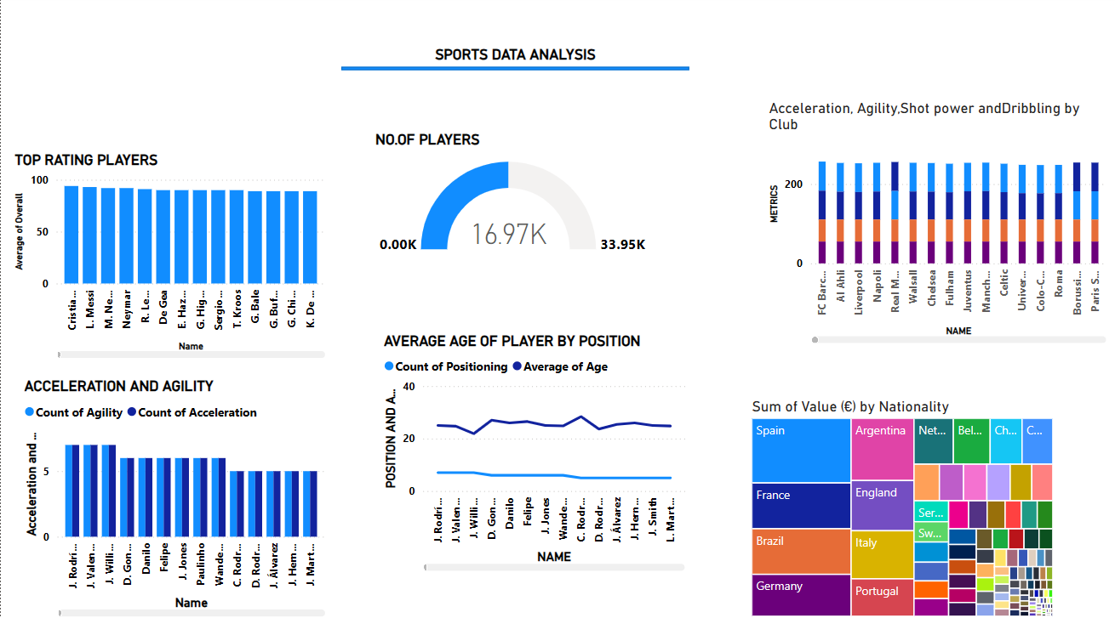

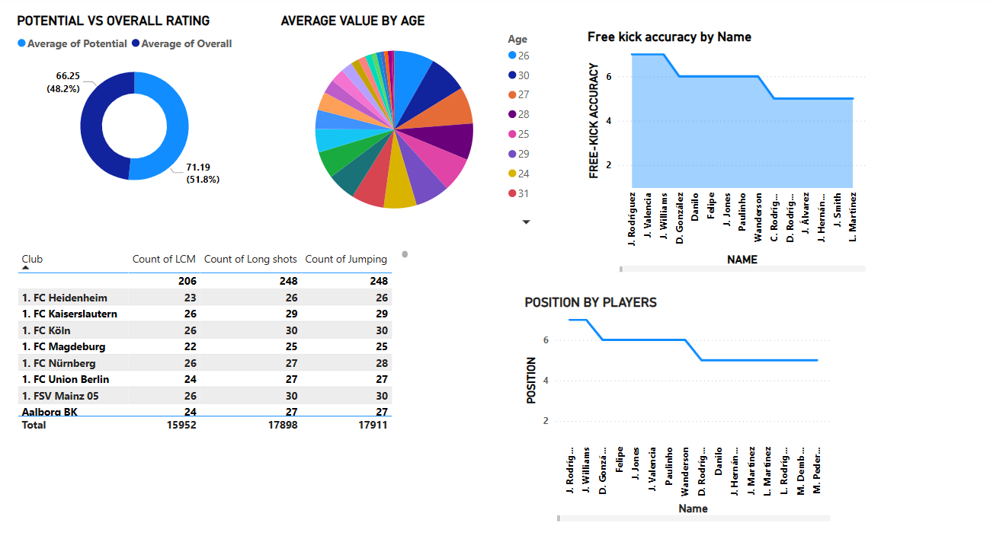

For the MS Excel database, I have cleaned and organized the data to minimize missing and inconsistent values, ensuring it is properly structured. I also created various visualizations to enhance data insights.

MS EXCEL

* Separated names into first and last names
* Applied proper letter casing
* Consistency, aligned all values to the centre
* Removed any blank cell

**DATA VISUALIZATION**

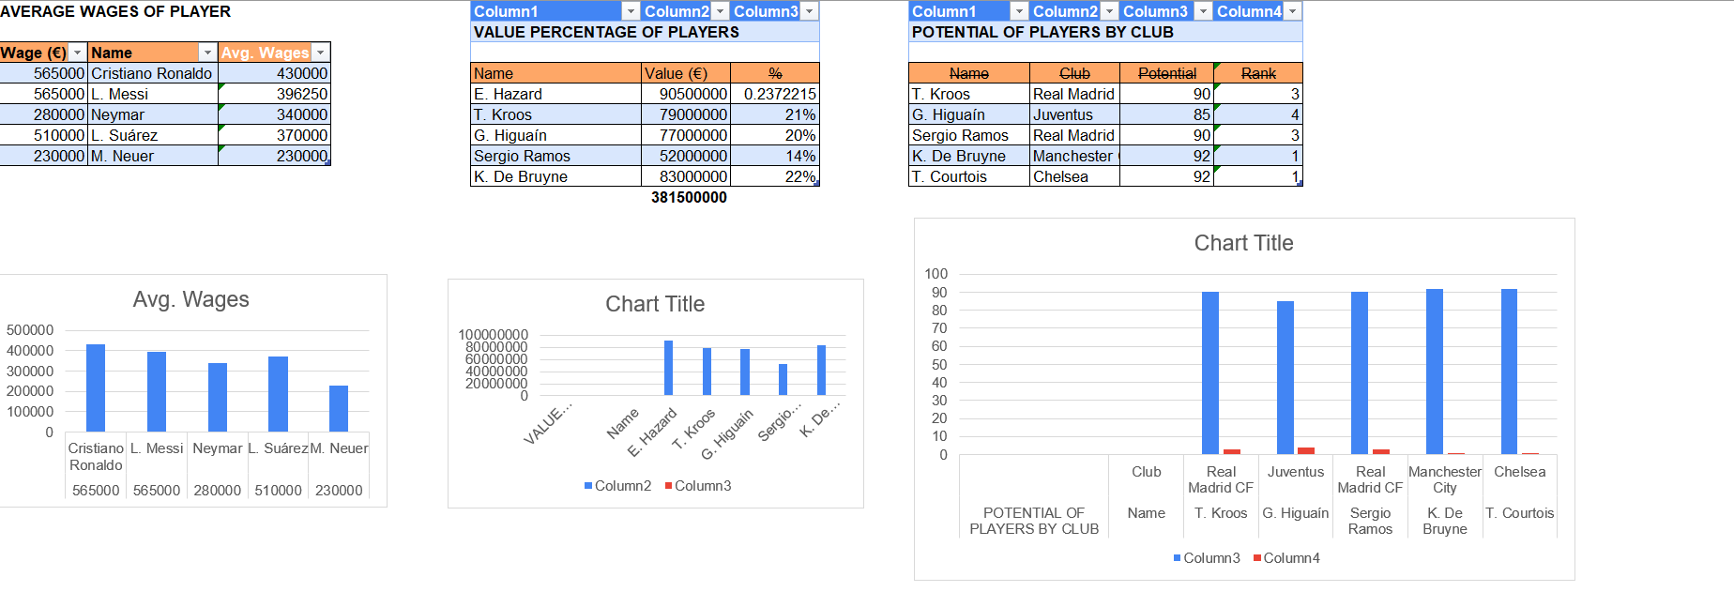

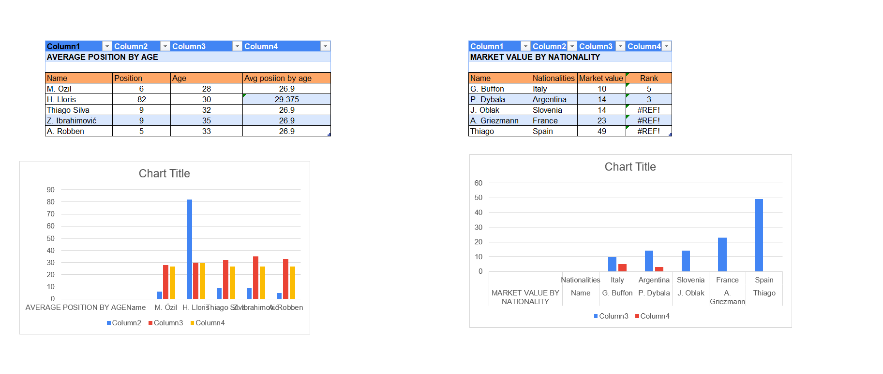

**SOCCER PLAYER PERFORMANCE ANALYSIS**

**SQL**

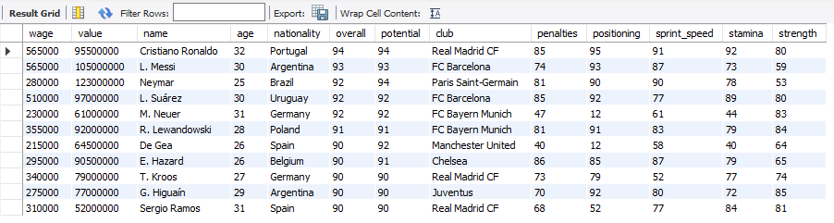

**"This is the table I created for analyzing soccer player performance."**

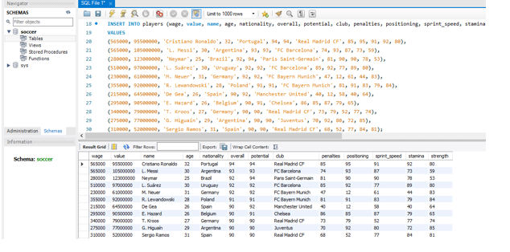

**Database : Soccer**

**Table : Football**

**High wages players**

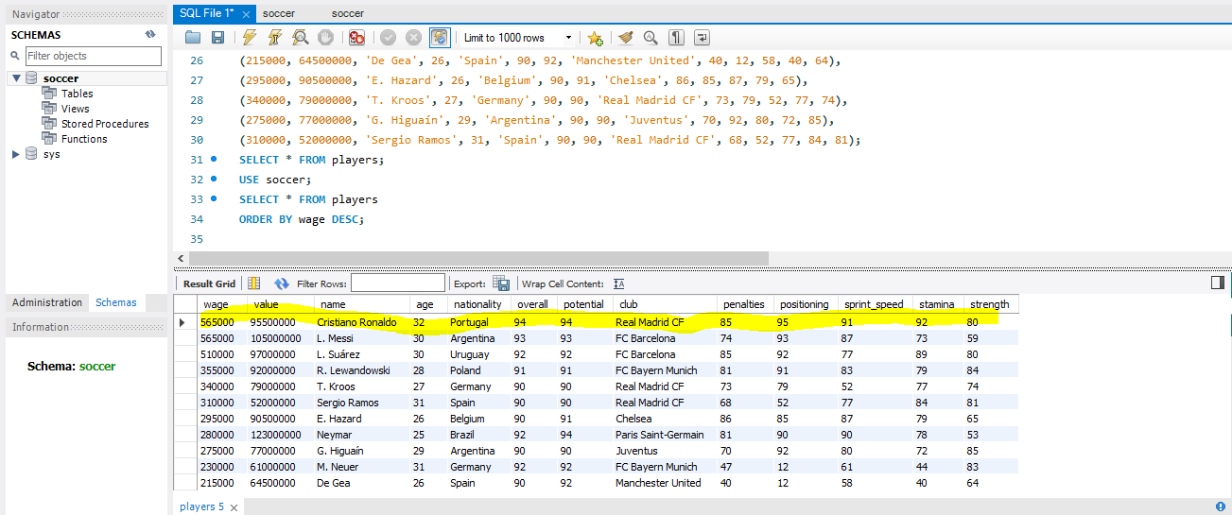

**From this table, we can see that Cristiano Ronaldo has the highest wage.**

**High-value players**

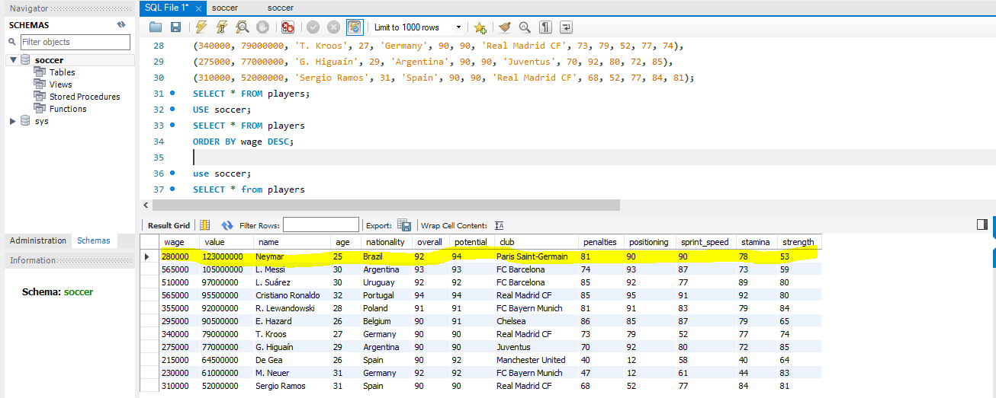

**It seems like you're looking to analyze the data in the table. From the provided information, Neymar has the highest value.**

**Overall rating by nationalities**

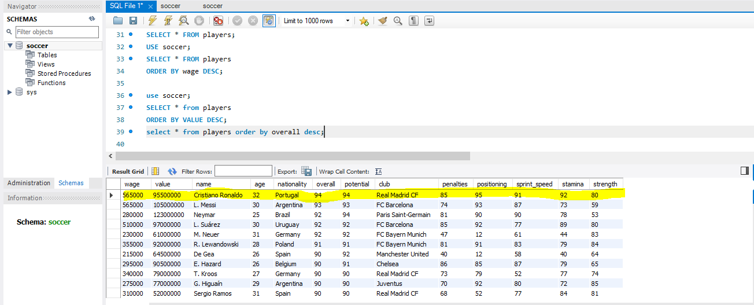

**Here we know that Cristiano Ronaldo is the top player in overall rating and belongs to Portugal. Sergio Ramos is the lowest among all and he belongs to Spain.**

**Penalties above 80**

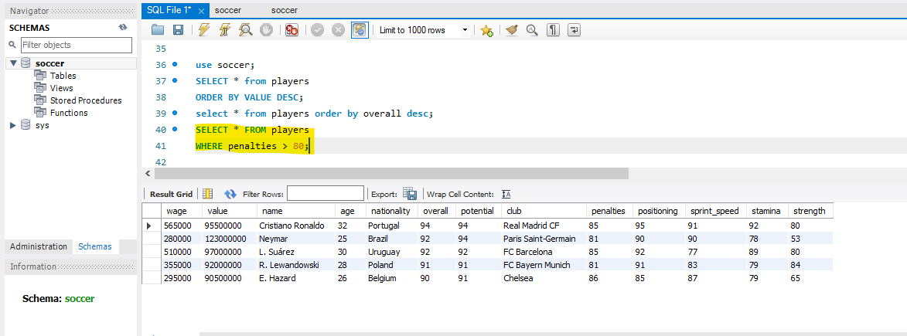

**Here we can see the list of players who have penalties above 80**

**Positioning**

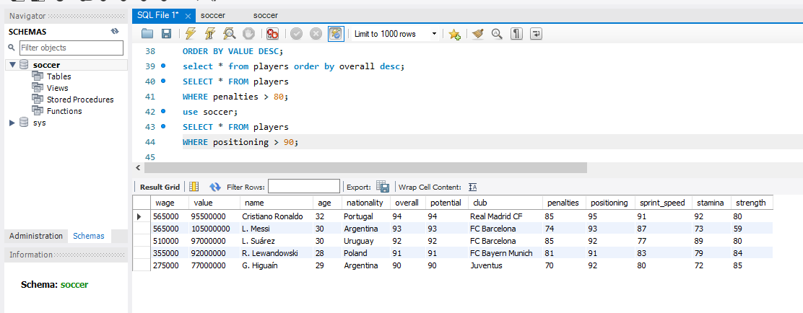

**Here is the position of players who scored above 90. Cristiano Ronaldo, Messi, Suarez, Lewandowski and Higuaín are the players**

**Stamina**

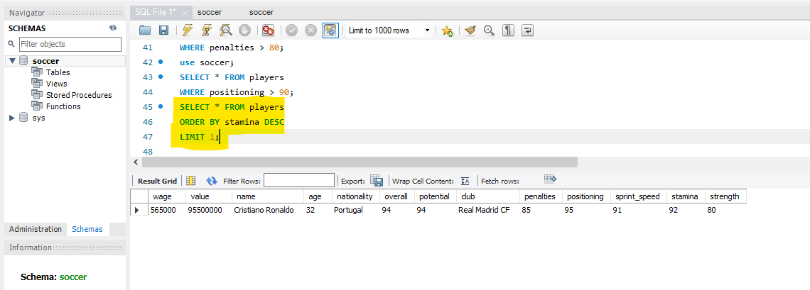

**In this table, we know Cristiano Ronaldo has the most stamina among all which is 92**

**Strength**

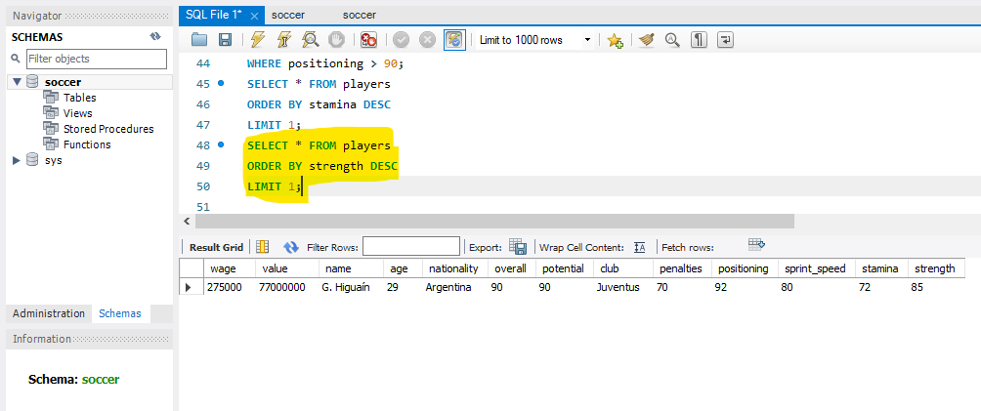

**Here I have sorted out the strength of players from descending to ascending , Higuaín is the top most among all.**

**Duplicate**

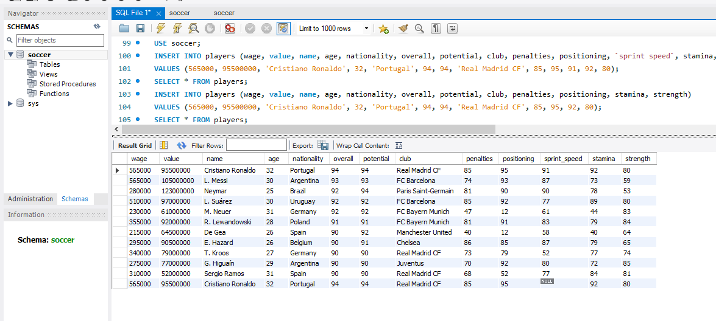

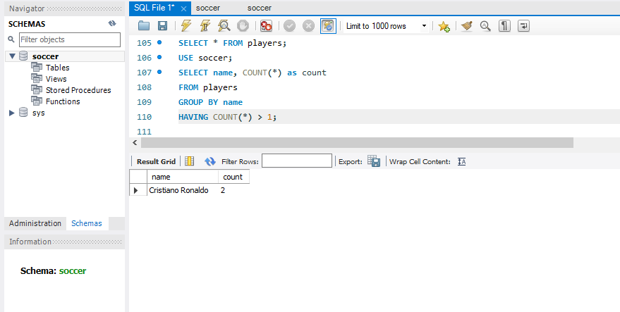

**Here I have used the duplicate syntax to identify the repeated player name, I the result we could see Cristiano Ronaldo is the repeating name.**

**Replace**

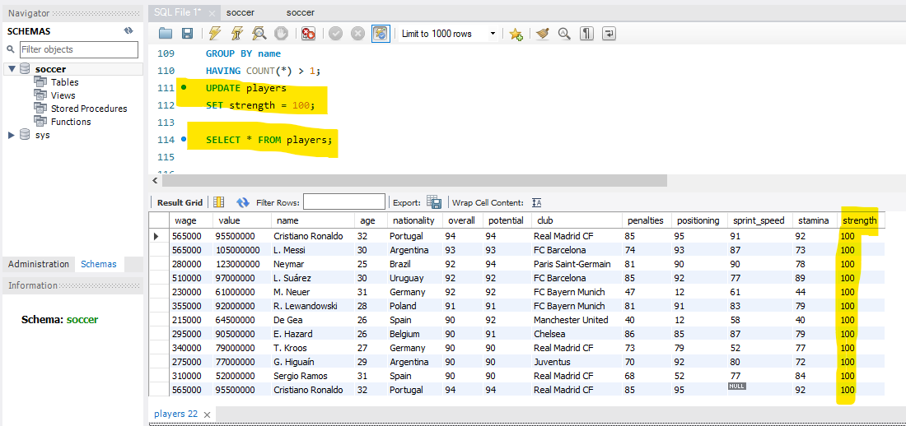

**Here I have used the update syntax to replace all strength values by 100.**

**Truncate**

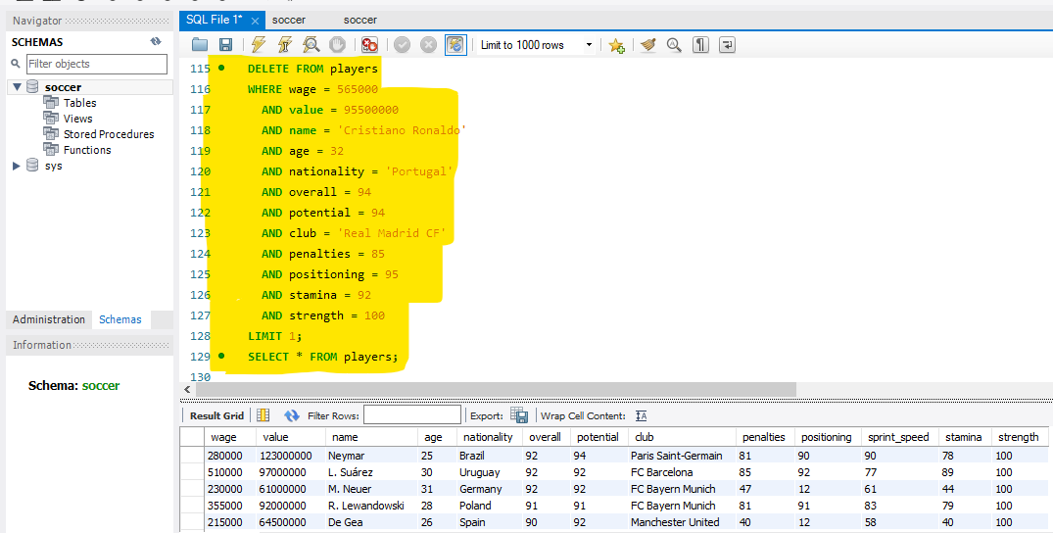

**This is the table where I have deleted some of the rows .**

**RECOMMENDATIONS AND SUGGESTION**

* **Player Scouting** -Create a scoring model to rank players based on performance metrics, with weights adjusted for team requirements.
* **Performance Analysis**-Develop visualizations to compare player performance, and identify ideal formations based on game scenarios.
* **Injury Prevention**- Analyse injury data to find common causes and predict future risks, develop dashboards to monitor physical and fitness metrics in real-time for early intervention.
* **Fan Engagement**- Create content based on popular players, key stats, and historical comparisons to increase fan interest, Track fan sentiments around player performances to inform communication strategies.
* **Contract Negotiation**- Benchmark players' performance against similar players within the league to validate salary proposals.

**Conclusion**:

The dashboard offers a comprehensive view of each player's performance metrics, such as goals, assists, pass accuracy, and defensive contributions. Integrating these metrics enables coaches and analysts to make informed decisions about player selection, tactical adjustments, and overall team strategy. Power BI's dynamic visuals (heatmaps, trend lines, bar charts) allow for quick, intuitive data interpretation. SQL serves as the backbone for data extraction and transformation, ensuring data consistency and minimizing manual errors. SQL queries enable quick updates and retrieval of real-time performance data, facilitating faster decision-making and more accurate reporting.